Microservice Deployment on Multiple Virtual Machines
By
Harika Korivi
M25AI2132
Objective
The goal of this project is to create and configure multiple Virtual Machines (VMs) using VirtualBox, establish a network between them, and deploy a simple microservice-based application. The application demonstrates communication between VMs over a private network.
1. Step-by-Step Instructions for Implementation
A. Installing VirtualBox and Ubuntu VMs
- Download and install VirtualBox on your Windows machine.
- Download Ubuntu 24.04 LTS ISO from the official Ubuntu website.
- Create two Virtual Machines (VMs):
  - VM1 Configuration:
    - Name: VM1
    - OS Type: Linux → Ubuntu (64-bit)
    - RAM: 2–4 GB
    - CPU: 2 cores
    - Hard disk: 30–40 GB, VDI, dynamically allocated
  - VM2 Configuration:
    - Same as VM1
- Attach the Ubuntu ISO to each VM and start the installation.
  - Follow the on-screen instructions to install Ubuntu.
  - Set username and password for each VM.
  - Complete installation and reboot the VM.
B. Configuring the Network Between VMs
- In VirtualBox, go to Tools → Network → NAT Networks → Create.
  - Name the network: M25AI2132
  - Leave other default settings.
- Assign each VM to this network:
  - Open VM Settings → Network → Adapter 1 → Attached to: NAT Network → Name: M25AI2132
- Boot both VMs and check IP addresses:
  - VM1: 192.168.100.3
  - VM2: 192.168.100.4
- Test connectivity:
ping 192.168.100.4 # From VM1
ping 192.168.100.3 # From VM2
  - Both VMs should respond successfully.
C. Installing Node.js and NPM
On both VMs, run the following commands:
sudo apt update
sudo apt install nodejs npm -y
node -v # Verify Node.js installation
npm -v # Verify NPM installation
D. Deploying a Simple Microservice
- Create a project folder on VM1:
mkdir vcc-microservice
cd vcc-microservice
- Initialize Node.js project:
npm init -y
- Create index.js with a simple REST API:
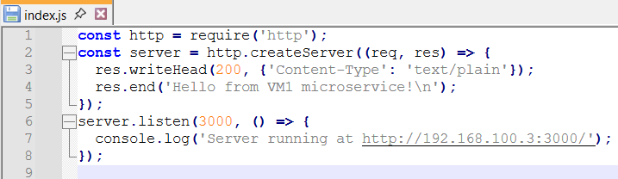
- Run the microservice:
node index.js
- Test the service from VM2:
curl http://192.168.100.3:3000
Expected output: Hello from VM1 microservice!

2. Architecture Design
- VM1: Hosts the microservice (Node.js REST API) on port 3000.
- VM2: Acts as a client that consumes the microservice via HTTP requests.
- Network: Both VMs are connected through a NAT Network named M25AI2132. This ensures secure communication in a private virtual network.
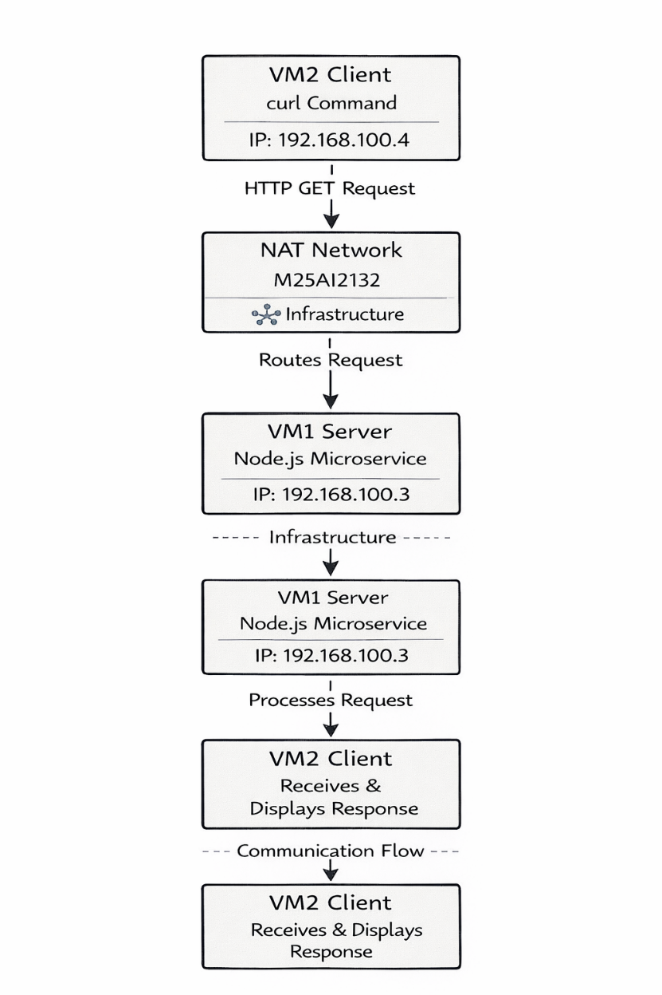
Conclusion
In this project, we successfully created and configured Virtual Machines using VirtualBox and established a private NAT network to enable communication between them. A simple Node.js microservice was deployed on VM1 and tested from VM2, demonstrating inter-VM interaction and the request-response flow. The architecture illustrates how infrastructure, microservices, technology stack, and communication flow work together to deliver a functional microservice-based application. This exercise provides practical experience in virtualized environments, network configuration, and microservice deployment, and lays a foundation for scaling to more complex distributed applications in real-world scenarios.

Google drive link for recording and source code: https://drive.google.com/drive/folders/18puKJAgCh7X_m5yH8y-OdW3SttyFid8P?usp=drive_link

